This document will show you how to add a student to a schedule using the Single Student Scheduler. For this to work you must have a Single Student Scheduler Parameter set up. You can verify this by going to:
Home » Management » School Administration » Scheduling Administration » Scheduler » Job Parameter Sets
If you do not, please contact LACA for assistance.
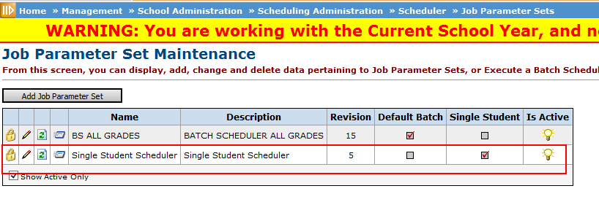

Step 1: Select a student in the student context area.

Step 2: Go to Home » SIS » Scheduling » Requests
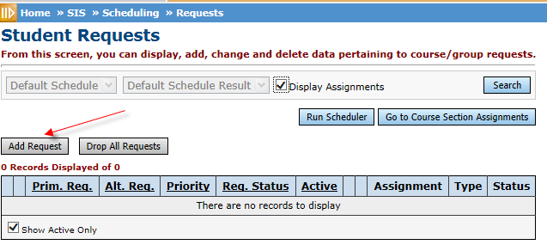
Step 3: Add requests for the student by clicking Add Request button.

Step 4: Enter the Course Code into Primary Course and hit Save and New if you need to add another course, or just hit Save.
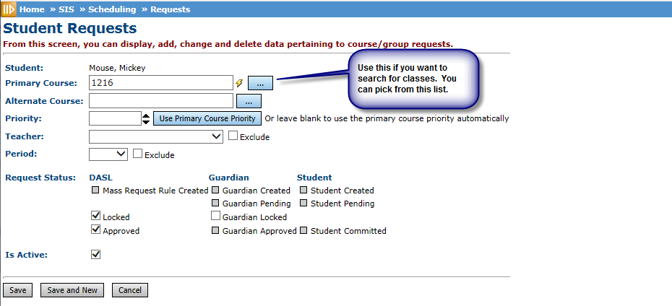

Step 5: Once all the requests have been entered, Select Run Scheduler to run the Single Student Scheduler.
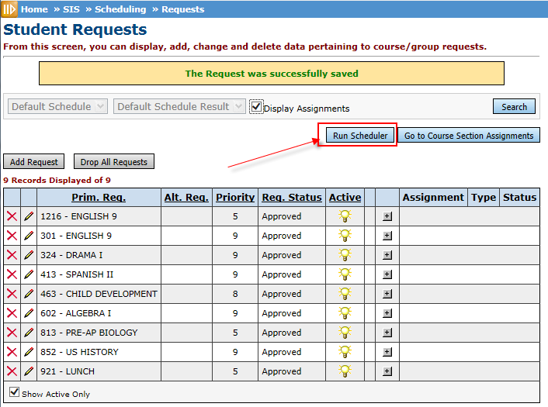

Step 6: Save Changes!
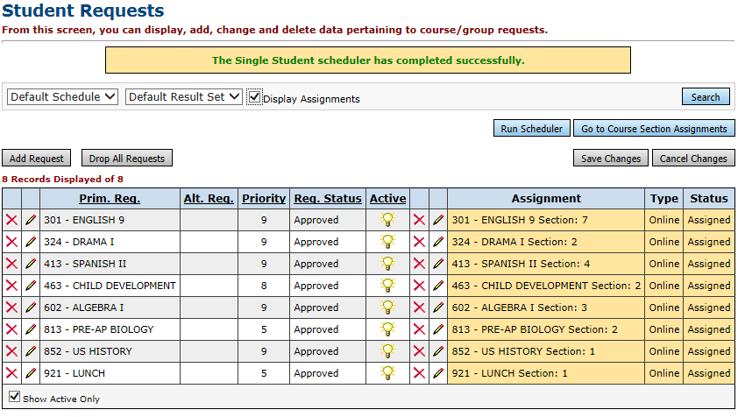

This example shows that there are no conflicts, but sometime courses are not available or overfilled. You may need to make adjustments before you save. Using the pencil you can manually assign to correct some of the conflicts.

